**Spring Boot Application with Prime Faces**

**Tools :**

IntelliJ IDEA

**Project Structure:**

i. Java files :

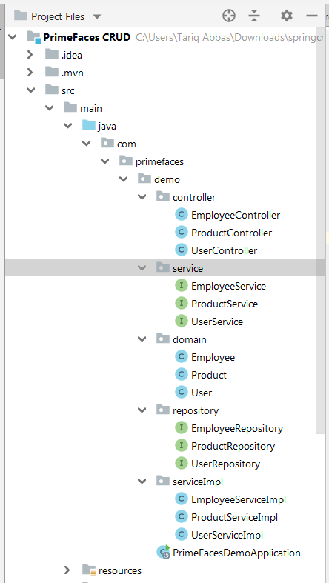

View (.xhtml) files :

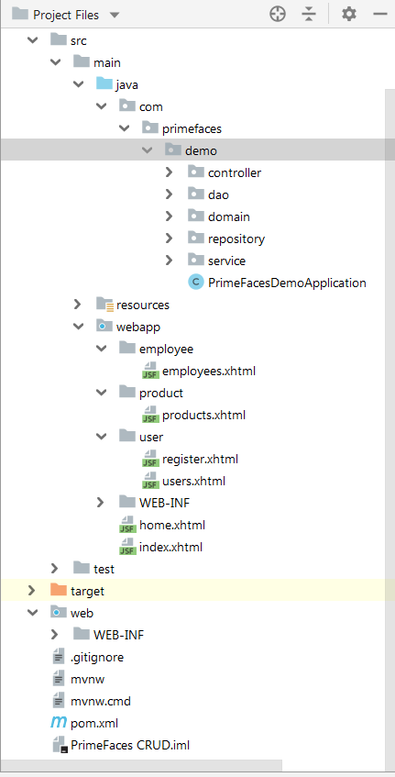

**Maven Dependencies :**

**pom.xml :**

i. Spring boot dependencies :

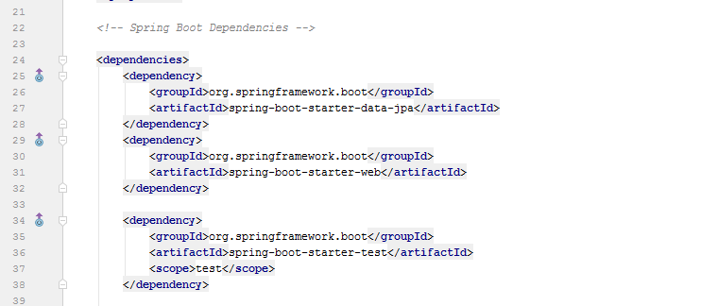

ii. Java Server Faces (JSF) and Prime Faces dependencies :

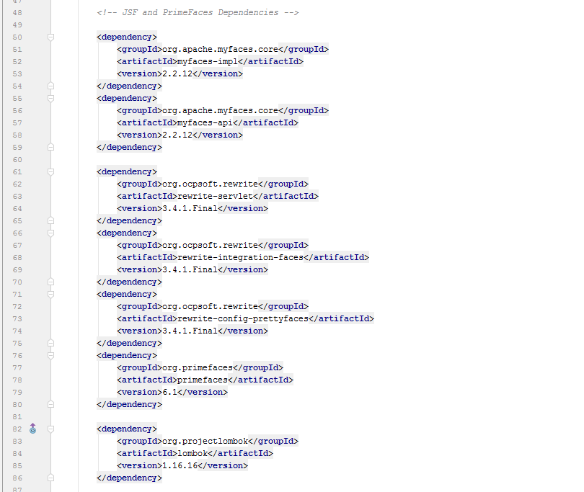

ii. H2 database dependency :

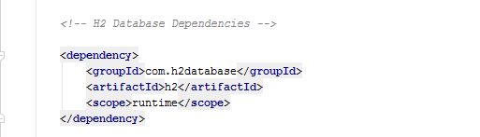

ii. Remaining dependencies and class path location :

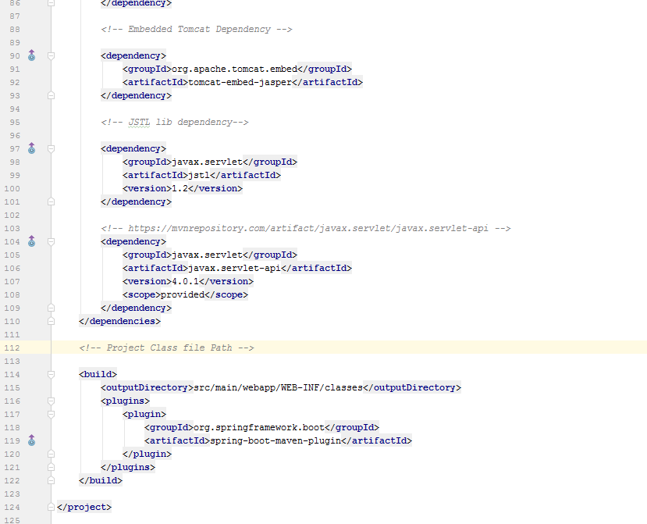

**Product Operations :**

i. Product View

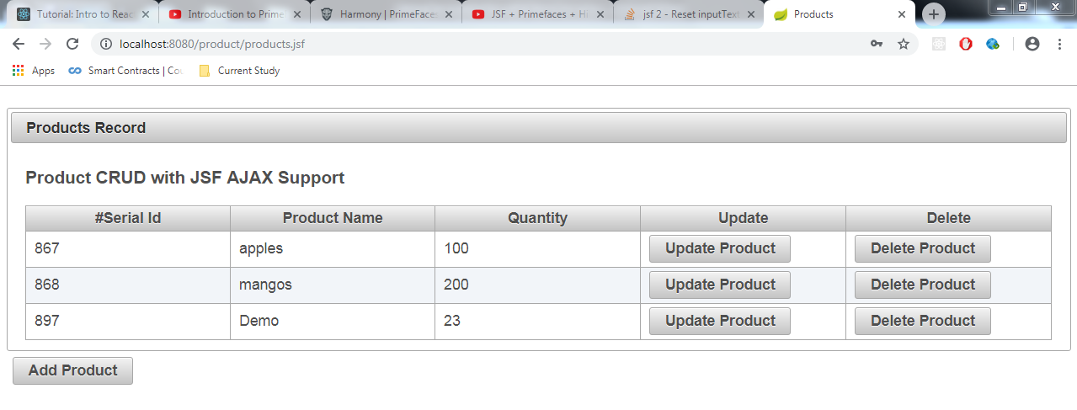

ii. Product adding new record :

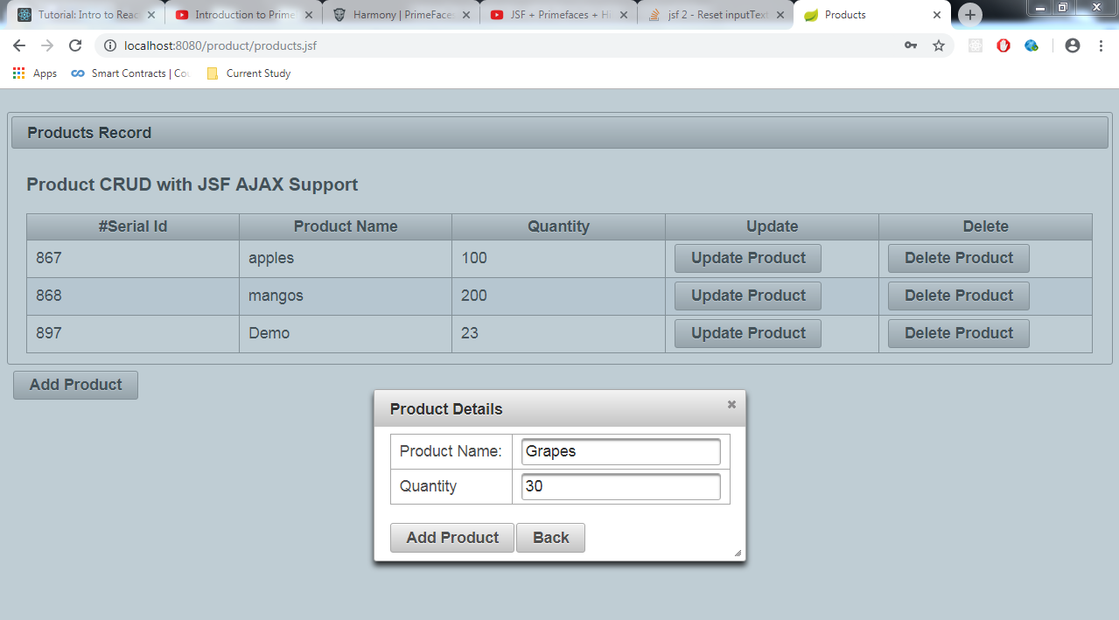

iii. Product add operation result :

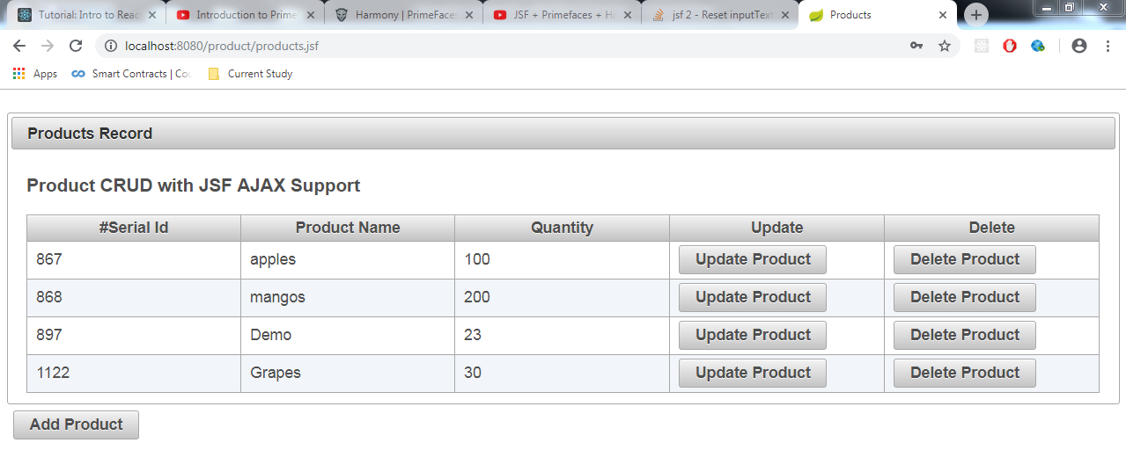

iv. Product update operation result :

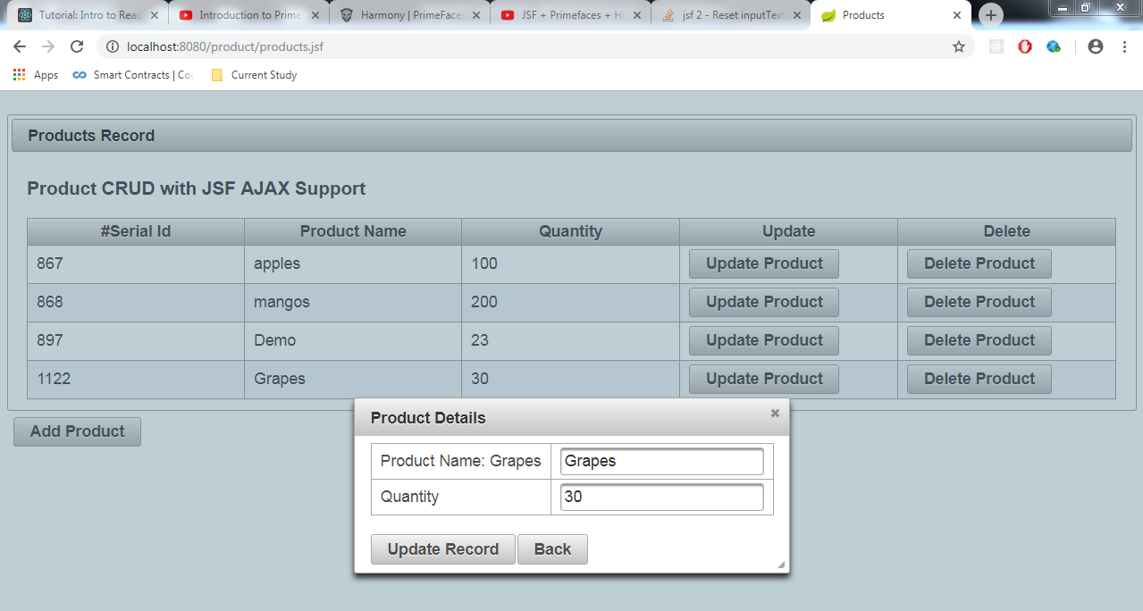

v. Product update operation result :

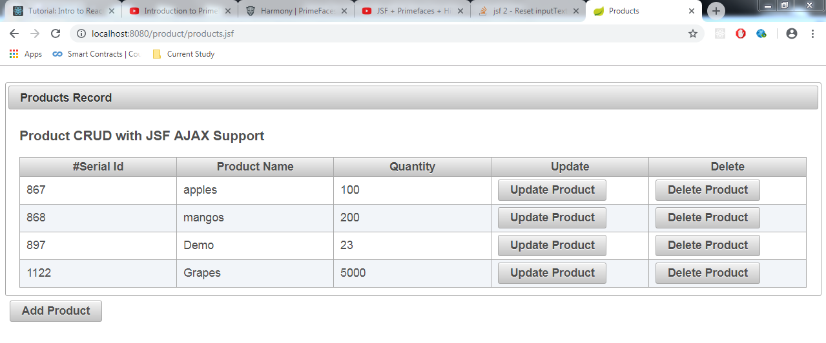

vi. Product delete operation result :

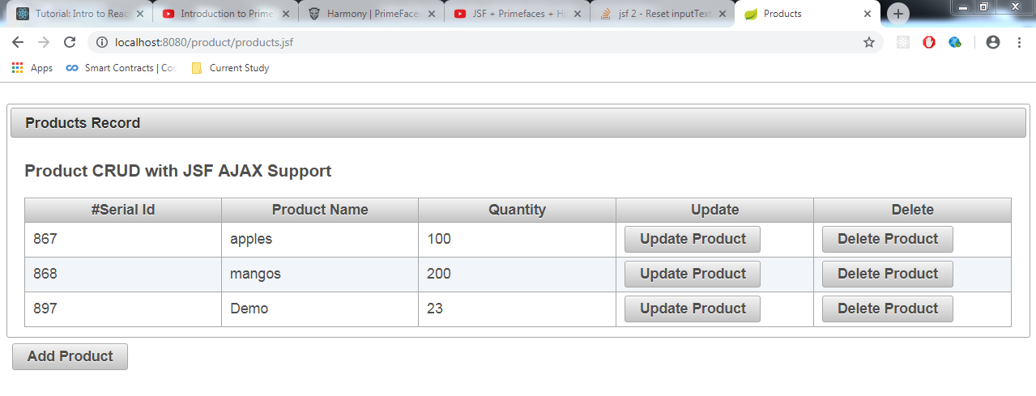

**Employee CRUD operations :**

i. Employee view :

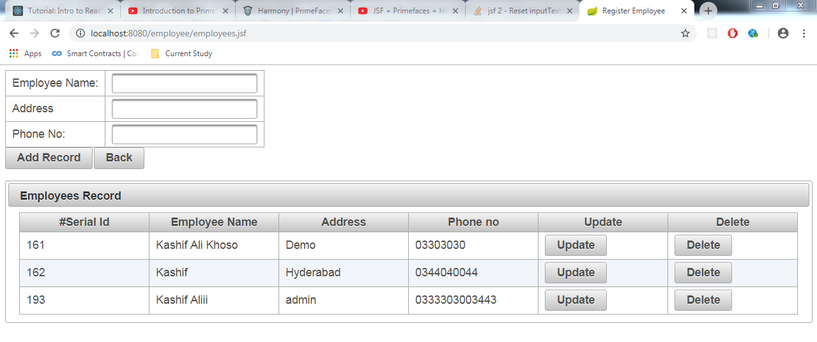

ii. Employee add operation:

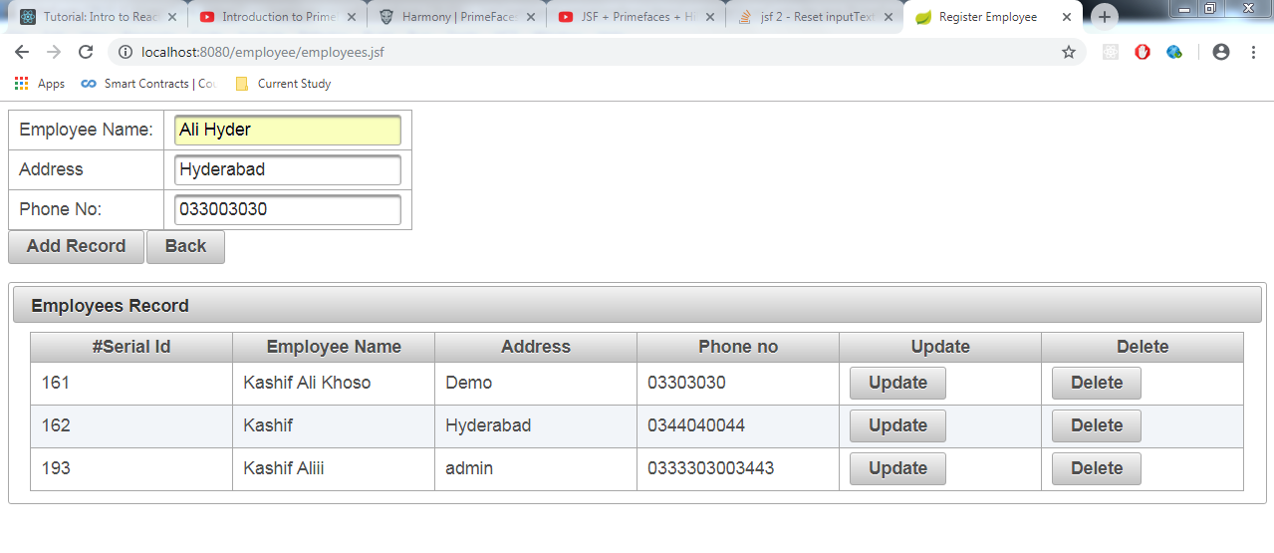

iii. Employee add operation result :

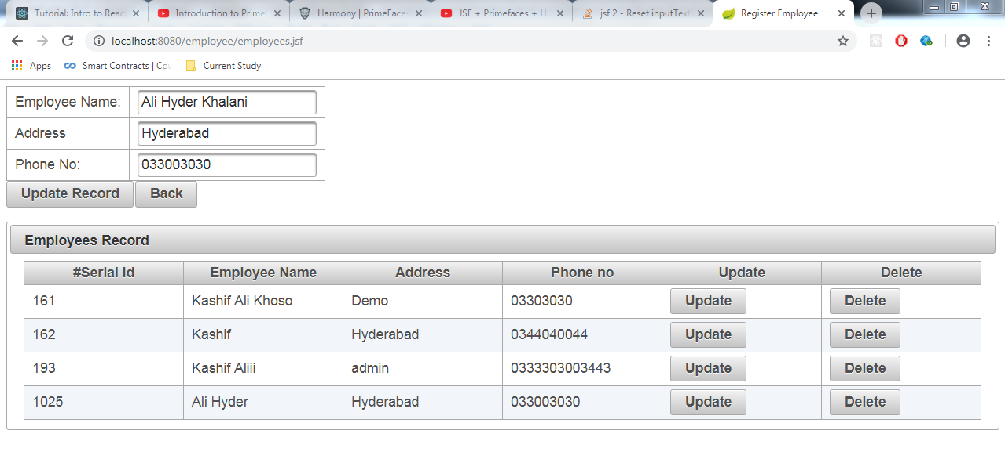

iv. Employee update operation result :

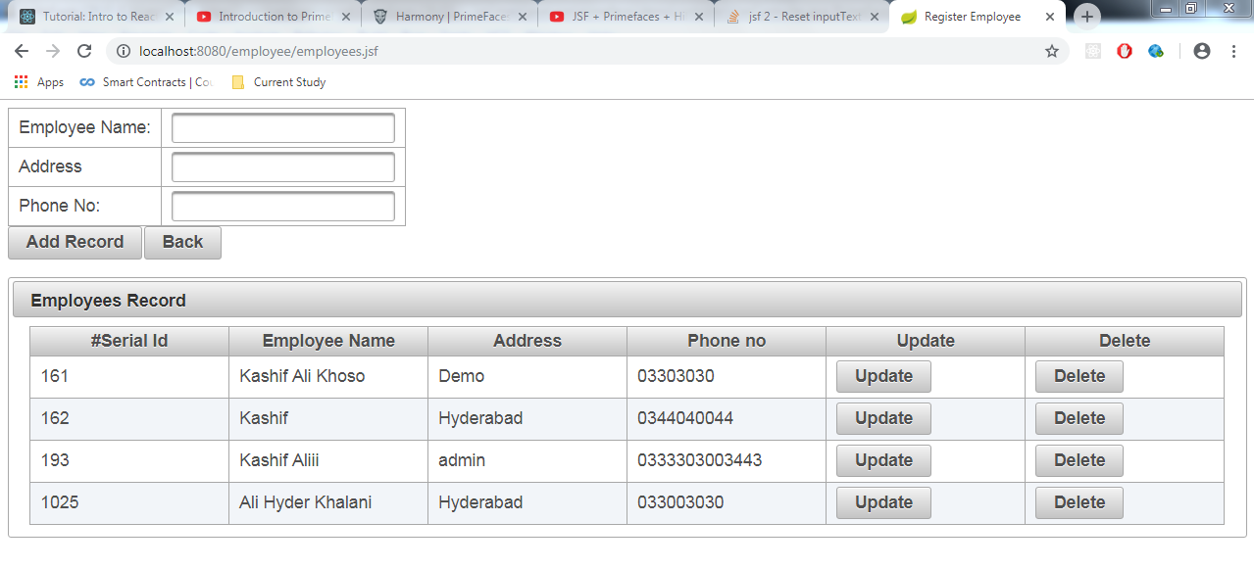

v. Employee delete operation result :

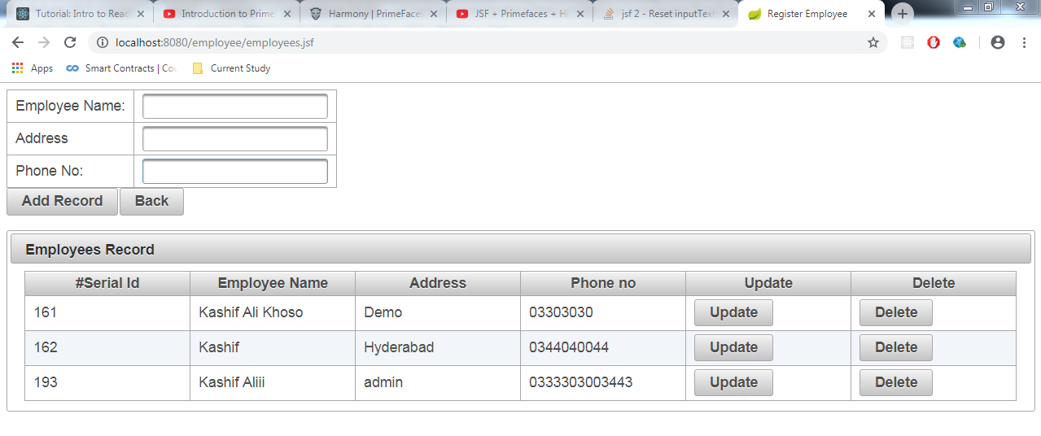

**User CRUD Operations :**

i. User view :

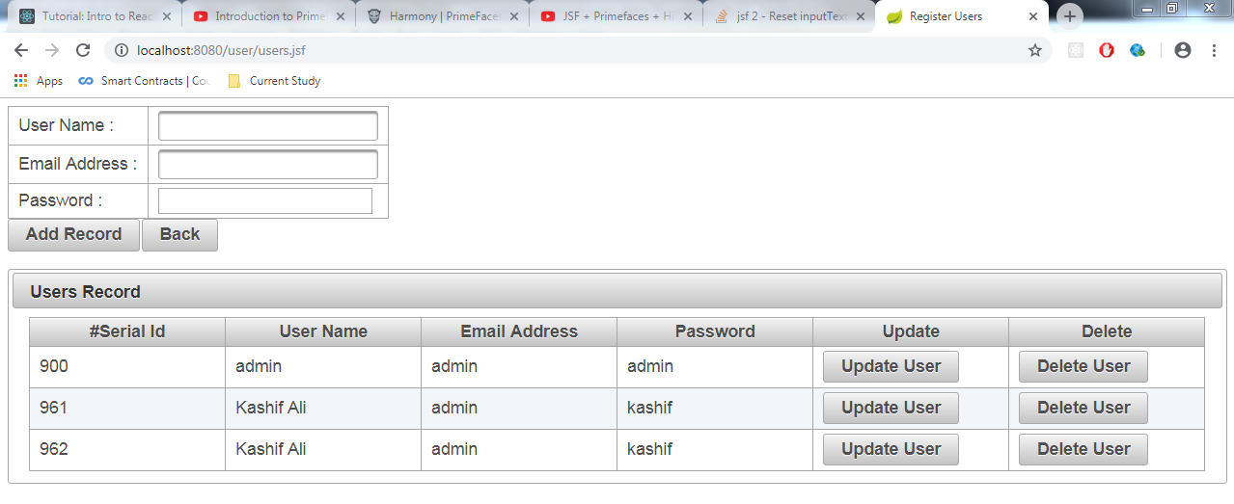

ii. User add operation :

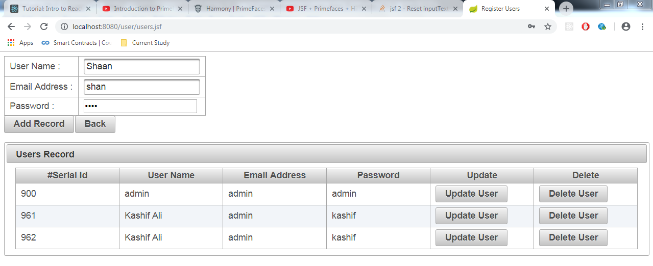

iii. User add operation result :

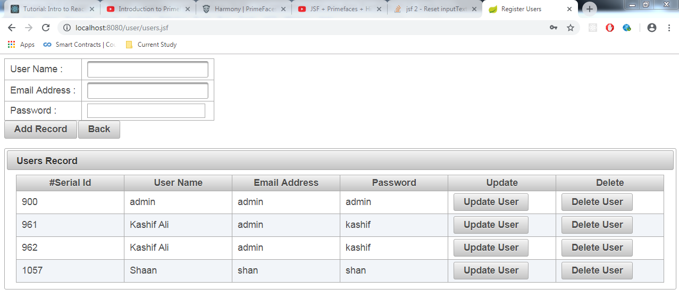

iv. User update operation:

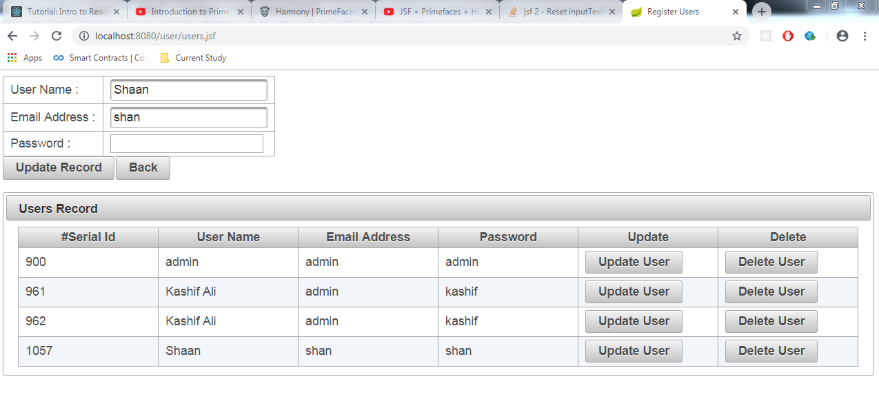

v. User update operation result :

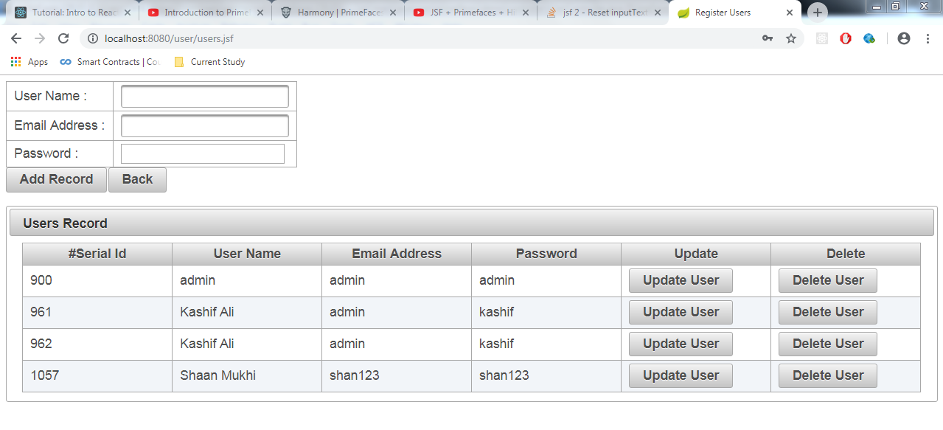

vi. User delete operation result :

